INPUT

# TASK 1

#IMPORT MODULES

import pandas as pd

import matplotlib.pyplot as plt

import seaborn as sns

# Load data

data = pd.read_csv("/content/test.csv")

# Display first and last rows of the dataframe

print("HEAD DATA")

print(data.head())

print("*-*-*-*-*-*-*-*-*-*-*-*-*-*-*-*-*-*-*-*-*-*-*-*-*-*-*-*-*-*-*-*-*-*-*-*-*-*-*")

print("TAIL DATA")

print(data.tail())

print("*-*-*-*-*-*-*-*-*-*-*-*-*-*-*-*-*-*-*-*-*-*-*-*-*-*-*-*-*-*-*-*-*-*-*-*-*-*-*")

# DATA DESCRIPTION

print(" DISPLAY BASIC STATISTICS AND INFO")

print(data.describe())

print(data.info())

print("*-*-*-*-*-*-*-*-*-*-*-*-*-*-*-*-*-*-*-*-*-*-*-*-*-*-*-*-*-*-*-*-*-*-*-*-*-*-*")

# HANDLING MISSING VALUES

print(" CHECK FOR MISSING VALUES")

print(data.isnull().sum())

print("*-*-*-*-*-*-*-*-*-*-*-*-*-*-*-*-*-*-*-*-*-*-*-*-*-*-*-*-*-*-*-*-*-*-*-*-*-*-*")

# VERIFY MISSING VALUES

print(" VERIFY THAT THERE ARE NO MORE MISSING VALUES")

print(data.isnull().sum())

# HANDLING DUPLICATE VALUES

print(" CHECK FOR DUPLICATE ROWS")

print(data.duplicated().sum())

# CONSTRUCT HISTOGRAM

print("PLOT AGE DISTRIBUTION")

plt.figure(figsize=(6, 3))

sns.histplot(data["Age"], kde=True)

plt.title("AGE DISTRIBUTION")

plt.xlabel("AGE")

plt.ylabel("COUNT")

plt.show()

#CONSTRUCT HISTOGRAM 2

print("SURVIVAL BY GENDER")

plt.figure(figsize=(6, 3))

sns.histplot(data=data,x="Sex",hue="Sex")

plt.title("SURVIVAL BY GENDER")

plt.xlabel("Gender")

plt.ylabel("Count")

plt.show()

#CONSTRUCT SCATTER PLOT

print("SCATTER PLOT")

plt.figure(figsize=(6, 3))

sns.histplot(data=data,x="Age",y="Fare",hue="Sex")

plt.title("SCATTERPLOT OF AGE AND FARE")

plt.xlabel("AGE")

plt.ylabel("FARE")

plt.show()

OUTPUT

HEAD DATA

PassengerId Pclass Name Sex \

0 892 3 Kelly, Mr. James male

1 893 3 Wilkes, Mrs. James (Ellen Needs) female

2 894 2 Myles, Mr. Thomas Francis male

3 895 3 Wirz, Mr. Albert male

4 896 3 Hirvonen, Mrs. Alexander (Helga E Lindqvist) female

Age SibSp Parch Ticket Fare Cabin Embarked

0 34.5 0 0 330911 7.8292 NaN Q

1 47.0 1 0 363272 7.0000 NaN S

2 62.0 0 0 240276 9.6875 NaN Q

3 27.0 0 0 315154 8.6625 NaN S

4 22.0 1 1 3101298 12.2875 NaN S

*-*-*-*-*-*-*-*-*-*-*-*-*-*-*-*-*-*-*-*-*-*-*-*-*-*-*-*-*-*-*-*-*-*-*-*-*-*-*

TAIL DATA

PassengerId Pclass Name Sex Age SibSp \

413 1305 3 Spector, Mr. Woolf male NaN 0

414 1306 1 Oliva y Ocana, Dona. Fermina female 39.0 0

415 1307 3 Saether, Mr. Simon Sivertsen male 38.5 0

416 1308 3 Ware, Mr. Frederick male NaN 0

417 1309 3 Peter, Master. Michael J male NaN 1

Parch Ticket Fare Cabin Embarked

413 0 A.5. 3236 8.0500 NaN S

414 0 PC 17758 108.9000 C105 C

415 0 SOTON/O.Q. 3101262 7.2500 NaN S

416 0 359309 8.0500 NaN S

417 1 2668 22.3583 NaN C

*-*-*-*-*-*-*-*-*-*-*-*-*-*-*-*-*-*-*-*-*-*-*-*-*-*-*-*-*-*-*-*-*-*-*-*-*-*-*

DISPLAY BASIC STATISTICS AND INFO

PassengerId Pclass Age SibSp Parch Fare

count 418.000000 418.000000 332.000000 418.000000 418.000000 417.000000

mean 1100.500000 2.265550 30.272590 0.447368 0.392344 35.627188

std 120.810458 0.841838 14.181209 0.896760 0.981429 55.907576

min 892.000000 1.000000 0.170000 0.000000 0.000000 0.000000

25% 996.250000 1.000000 21.000000 0.000000 0.000000 7.895800

50% 1100.500000 3.000000 27.000000 0.000000 0.000000 14.454200

75% 1204.750000 3.000000 39.000000 1.000000 0.000000 31.500000

max 1309.000000 3.000000 76.000000 8.000000 9.000000 512.329200

<class 'pandas.core.frame.DataFrame'>

RangeIndex: 418 entries, 0 to 417

Data columns (total 11 columns):

# Column Non-Null Count Dtype

--- ------ -------------- -----

0 PassengerId 418 non-null int64

1 Pclass 418 non-null int64

2 Name 418 non-null object

3 Sex 418 non-null object

4 Age 332 non-null float64

5 SibSp 418 non-null int64

6 Parch 418 non-null int64

7 Ticket 418 non-null object

8 Fare 417 non-null float64

9 Cabin 91 non-null object

10 Embarked 418 non-null object

dtypes: float64(2), int64(4), object(5)

memory usage: 36.0+ KB

None

*-*-*-*-*-*-*-*-*-*-*-*-*-*-*-*-*-*-*-*-*-*-*-*-*-*-*-*-*-*-*-*-*-*-*-*-*-*-*

CHECK FOR MISSING VALUES

PassengerId 0

Pclass 0

Name 0

Sex 0

Age 86

SibSp 0

Parch 0

Ticket 0

Fare 1

Cabin 327

Embarked 0

dtype: int64

*-*-*-*-*-*-*-*-*-*-*-*-*-*-*-*-*-*-*-*-*-*-*-*-*-*-*-*-*-*-*-*-*-*-*-*-*-*-*

VERIFY THAT THERE ARE NO MORE MISSING VALUES

PassengerId 0

Pclass 0

Name 0

Sex 0

Age 86

SibSp 0

Parch 0

Ticket 0

Fare 1

Cabin 327

Embarked 0

dtype: int64

CHECK FOR DUPLICATE ROWS

0

PLOT AGE DISTRIBUTION

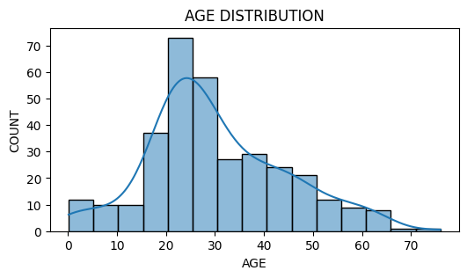

SURVIVAL BY GENDER

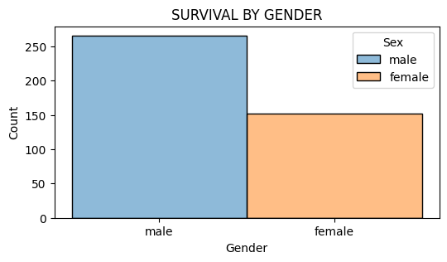

SCATTER PLOT

